Positive Behavior Interventions and Supports

handbook
  - FY 2016
DSSS

Introduction to Positive Behavior Interventions and Supports……………………………………………………[p1]
School-Wide Rules – Description………………………………………………………………………………………[p2]
School Rules Poster……………………………………………………………………………………………………………….[p3]
Teaching School-Wide Rules, Expectations, & Routines - Description………………………………………[p4]
Expectations Grid……………………………………………………………………………………………………………….[p5]
Lesson Plans across Settings…………………………………………………………………………………..[p6]
Acknowledgement System - Overview……………………………………………………………………………………….[p8]
Acknowledgement Coupon……………………………………………………………………………………………………[p9]
Consequence System Overview………………………………………………………………………………………………[p10]
Office Referral Form……………………………………………………………………………………………………………..[p11]

What is Positive Behavior Interventions and Supports?
Positive Behavior Interventions and Supports (PBIS) is an approach to supporting students to be successful in schools. PBIS was developed from research in the fields of behavior theory and effective instruction. PBIS supports all students through intervention ranging from a school-wide system to a system for developing individualized plans for specific students. School-wide PBIS focuses on the development and implementation of pro-active procedures and practices to prevent problem behavior for all students and improve school climate.
Who is on the School-wide PBIS Team?
The PBIS team is representative of the entire school staff across grade levels, classified staff, Special Education staff, etc. Teams are also encouraged to have a family member. Having a representative team will improve communication and feedback about PBIS programs in the school and should also improve involvement and buy-in throughout the school. The current PBIS team consists of the following members:
Dave Murgia, Principal Melissa Bishop, Education Specialist, Parent
Anne McLean, PBIS Team Leader Kate Miller, Education Specialist
Mary Gocke, Counselor Anna Connaughton, Instructional Aide, Parent
Jeanne O’Connell, Teacher

What are the responsibilities of the School-wide PBIS team?
- Hold PBIS meetings on-site once per month to plan and coordinate school-wide behavior systems. The team is responsible for planning PBIS activities and programs (such as PBIS Kick-Off, acknowledgment assemblies, and booster lessons of school rules) and continually monitoring and updating PBIS programs
- Attending district-wide meetings and trainings to promote the continuing development and maintenance of PBIS programs at your school.
- Present PBIS news and professional development at staff meetings to keep staff up to date with school PBIS programs and receive input and feedback from staff.
- The PBIS Team Leader is responsible for facilitating monthly PBIS meetings on-site and being the liaison with district PBIS efforts through PBIS District Leadership meetings held every other month.
The following pages describe the School-wide PBIS plans and programs for this year. It is expected that all school staff will be active participants in the school-wide programming, including General Education and Special Education staff, Certified and Classified staff, bus drivers and cafeteria and custodial staff, even volunteers and substitute teachers.

School-Wide Rules and Expectations

Be Respectful Be Responsible Be Safe

Why do we have School-wide Rules?
Having a few simple, positively stated rules facilitates the teaching of behavioral expectations across school settings because students will be learning through the same language. By focusing on 3 simple rules it is easier for students to remember. It is also important for staff because instruction focusing on a few simple rules will improve teaching and consistency across staff through the use of a common language.
Positively stated rules are important, because research has shown that recognizing students for following the rules is even more important than catching them breaking the rules. By stating rules positively, the hope is that staff will be more likely to use the rules to catch students engaging in the appropriate behavior.
By selecting only a few rules it is important that the rules are broad enough to talk about all potential problem behaviors. With the rules selected, the PBS team believes that we can then teach all specific behavioral expectations across all school setting according to these simple rules, for example:
• Thank you class for Being So Respectful by raising your hands to speak and listening to what everyone else had to say about the story.
• You were Being Very Responsible when you asked your classmate to walk in a straight line in the hallway.
• Cleaning up your spills in the cafeteria is an example of Being Safe because someone could slip on the spill and get hurt.
The Behavioral Expectations Matrix (see the following pages) uses the school-wide rules to identify specific behavioral expectations across all school settings.
All staff and students in the school are expected to know the School-wide Rules. Schools will be evaluated twice per year (Fall & Spring) to see if staff and students know the school-wide rules. The goals is that 90 % of staff and students know the school-wide rules. To be most effective, regular teaching using the school-wide rules should become part of the school culture.
School Rules Posters
School Rules Posters will be disseminated and should be posted in every room in the school, including all classrooms, the cafeteria, hallways, front office, etc. This will help to prompt staff and students to pay attention to the school rules. School Rules Posters should be big enough to read and highly visible throughout all settings in the school.

Teaching School-wide Rules, Behavioral Expectations, & Routines
Starting the Year off Right
During the first week of school, we focus on teaching school-wide rules, behavioral expectations, and routines to all students across all settings in the school. The PBIS team organizes a set of events to provide students and staff with an entertaining, memorable, and positive first week of school in which everyone learns the rules, expectations, and routines throughout the entire school. To truly start the year on a positive note we expect participation and support from the entire staff.
Why teach the Rules, Expectations, and Routines during the first week of school?
One of the major reasons to teach behavioral expectations and routines across settings is to ensure that all staff agree on what is expected with consistency. Surprisingly often, staff have different expectations about what behavior is acceptable in different settings which can confuse students.
A second major reason is that we cannot assume that students know the expectations and routines.
What are Routines?
Routines are the procedures and processes students are expected to follow to keep things running smoothly and prevent problems. Examples of routines include: appropriately entering the cafeteria, the lunch line process, the dismissal process for classes from lunch, process for sharpening a pencil in class, etc. Choosing routines should be a thoughtful process, since some routines can inadvertently set up students to engage in misbehavior. Routines should be taught and reinforced during the first week of school so that everyone is following the same set of procedures.
Booster Sessions: Re-teaching the Rules, Expectations, and Routines.
Like all good teachers, we must remember we cannot simply teach the expectations and routines once. It is important to hold booster sessions to review expectations. Booster sessions are especially helpful after returning from a long break, during times in the year when you anticipate having more troubles, or in areas that continue to be problematic. Booster sessions may include re-teaching expectations, increasing the number of acknowledgment tickets, or having a contest between classes to award the class that does the best with the identified expectations or in the specified area.
The following pages provide tools staff can use to guide the teaching of behavioral expectations according to the School-wide Rules, including:
• Sample Lesson Plans

Acknowledgment System
Why do we want to recognize expected behavior?
It is not enough just to teach expected behavior, we also need to regularly recognize and reward students for engaging in appropriate behavior. Research has shown that recognizing students for engaging in expected behavior is even more important than catching students breaking the rules. In fact, research on effective teaching has found that teachers should engage in a rate of 4 positive interactions with students to every 1 negative interaction (4:1 ratio). The goal of an acknowledgment system is to increase the number of positive interactions that all school staff have with students.
At Neal Dow Elementary School we use Paws for Play to acknowledge students for appropriate behavior. Through this program we hand out Dragon Paws, a positive reward, to students following the school rules.

When recognizing students with a Dragon Paw, it is important to identify specifically what behavior the student engaged in and link it to the appropriate school rule. For example:
Abby, I wanted to thank you for helping pick up the books someone knocked on the floor, you were being very responsible and it really helped me out. Here is a Dragon Paw.
Ideally, students should be given Dragon paws immediately following a postivie behavior and be told exactly why they received the token. In order to promote expected behavior it is important that students know when and why they are being acknowledged.
Who should be handing out acknowledgment tokens?
All staff members at the school should be provided with the acknowledgment tokens, including General and Special Education teachers, Classified staff, supervisors, and even substitute teachers.
How many tickets should be given out?
The goal is for the program to touch all students. All students should feel like they have a good chance of being recognized for good behavior. Even the most challenging students engage in appropriate behavior much of the time. The challenging students probably have more to benefit from such a program than other students.
How often should assemblies/ announcements be held to recognize students for positive behavior?
Once a trimester for assemblies. Assemblies are a chance to celebrate positive behavior and regularly re-teach students the school-wide rules. Each week students are recognized with prize drawings and in all-school announcements.

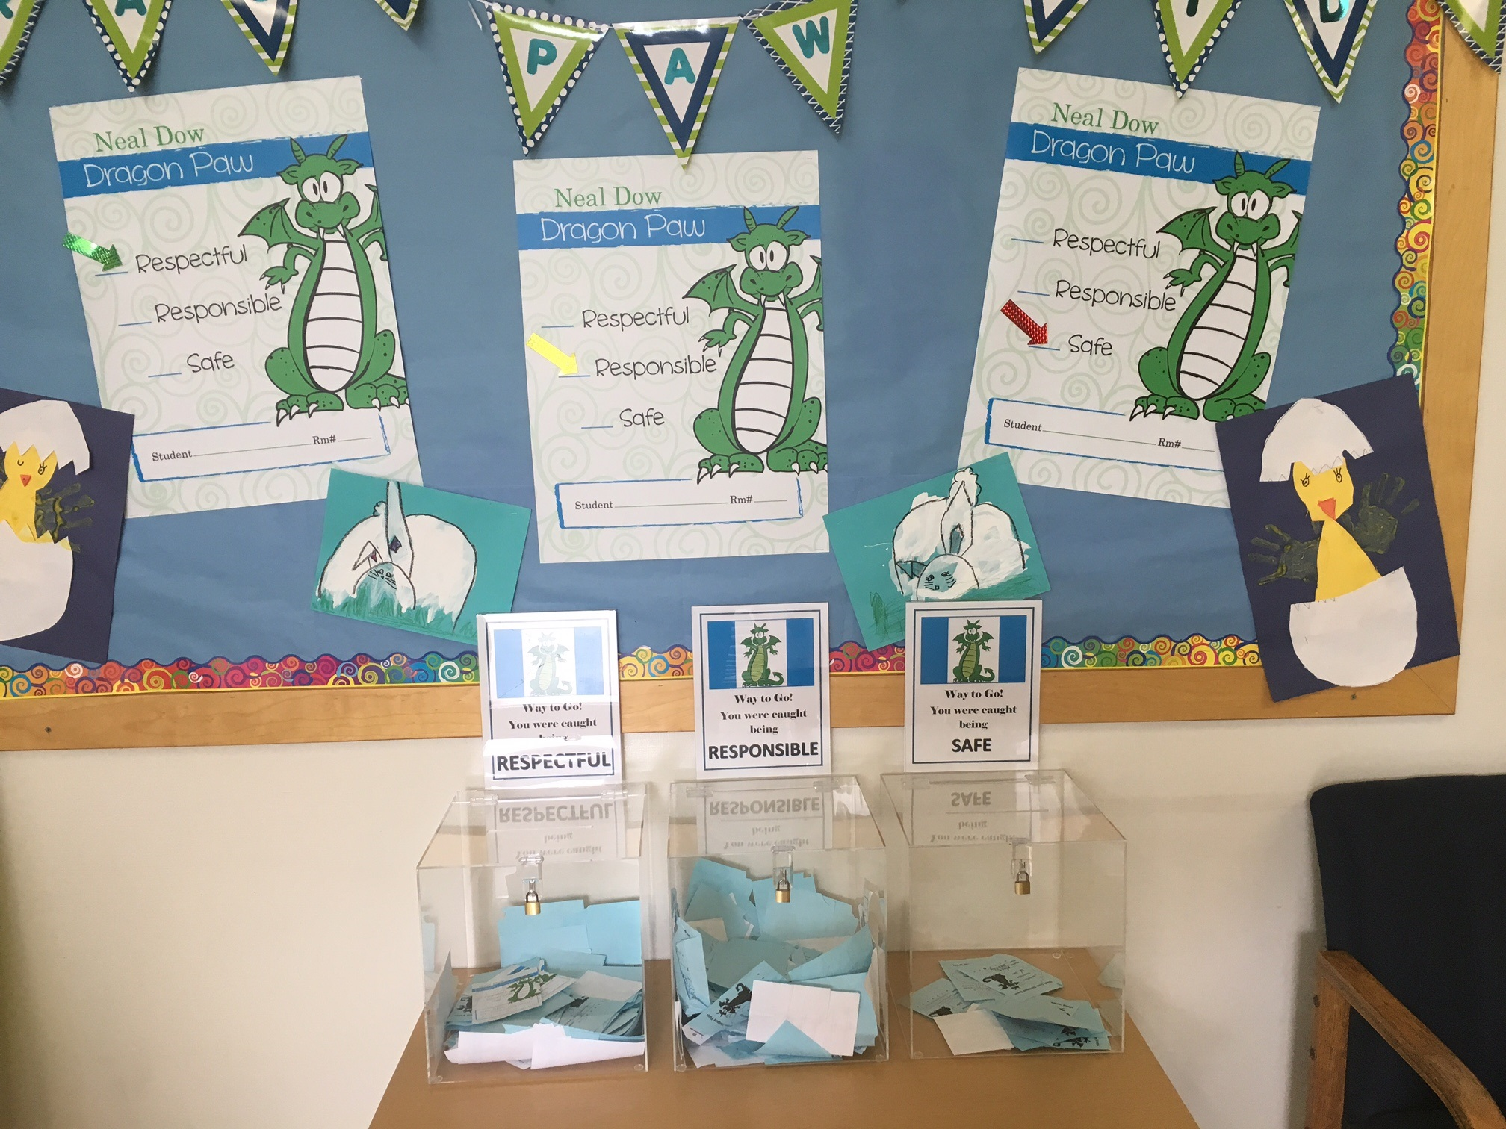

Consequence System
Consistent and fair discipline procedures are crucial to a successful consequence system. It is important that we are respectful of students in our disciplinary responses. Consequences should focus on teaching, remediation, or logical consequences as much as possible (i.e. if a student breaks a window they work it off in restitution, etc.). In providing consequences, we want to be mindful of minimizing the loss of instructional time students are missing.
In order to maximize student instructional time staff are encouraged to deal with problem behavior in their classroom as much as possible. This requires that staff develop a clear discipline plan, which teaches expectations and routines, incentives for positive behavior, and clear classroom responses to problem behavior for their classroom. If teachers are experiencing pervasive problem behavior in their classroom, they are advised to seek assistance or additional consultation by contacting the principal.
It is essential that staff and administration agree on the following:
• What problem behaviors should be sent to the office?
• What problem behaviors are expected to be dealt with in the classroom?
• What is the sequence of disciplinary responses in the school, or what alternatives are there?
• What are the procedures for an office referral?
The following pages contain materials outlining the consequence system at our school:
• Office Discipline Referral form

School-Wide Information System (SWIS)

Office referrals and suspensions are entered into a database that provides easy access to discipline information across the school and for individual students. The PBIS team will use discipline data on a monthly basis to make decisions about School-wide programming and individual students in need of additional support.
.

